1. (a) What is meant by a **programming paradigm**? [1]

(b) Name **three** different programming paradigms. [3]

(c) Why is there a need for different programming paradigms? [3]

(d) The following statements are written in a high level language that supports a particular programming paradigm. It consists of a number of facts and rules, from which questions can be answered and problems solved.

happy(mabel)

happy(gina)

sings(kelly)

sings(daniel) if happy(daniel)

sings(mabel) if happy(mabel)

(i) Give one example of a **fact** and one example of a **rule** in this program.

Fact: [1]

Rule: [1]

(iii) How will the program respond if the user enters the query:

sings(daniel)?

Program will respond: [1]

2. A school employs two different types of staff, Academic and Administrative.

Administrative staff are categorised as Office or Maintenance staff.

An incomplete diagram of the system is shown below.

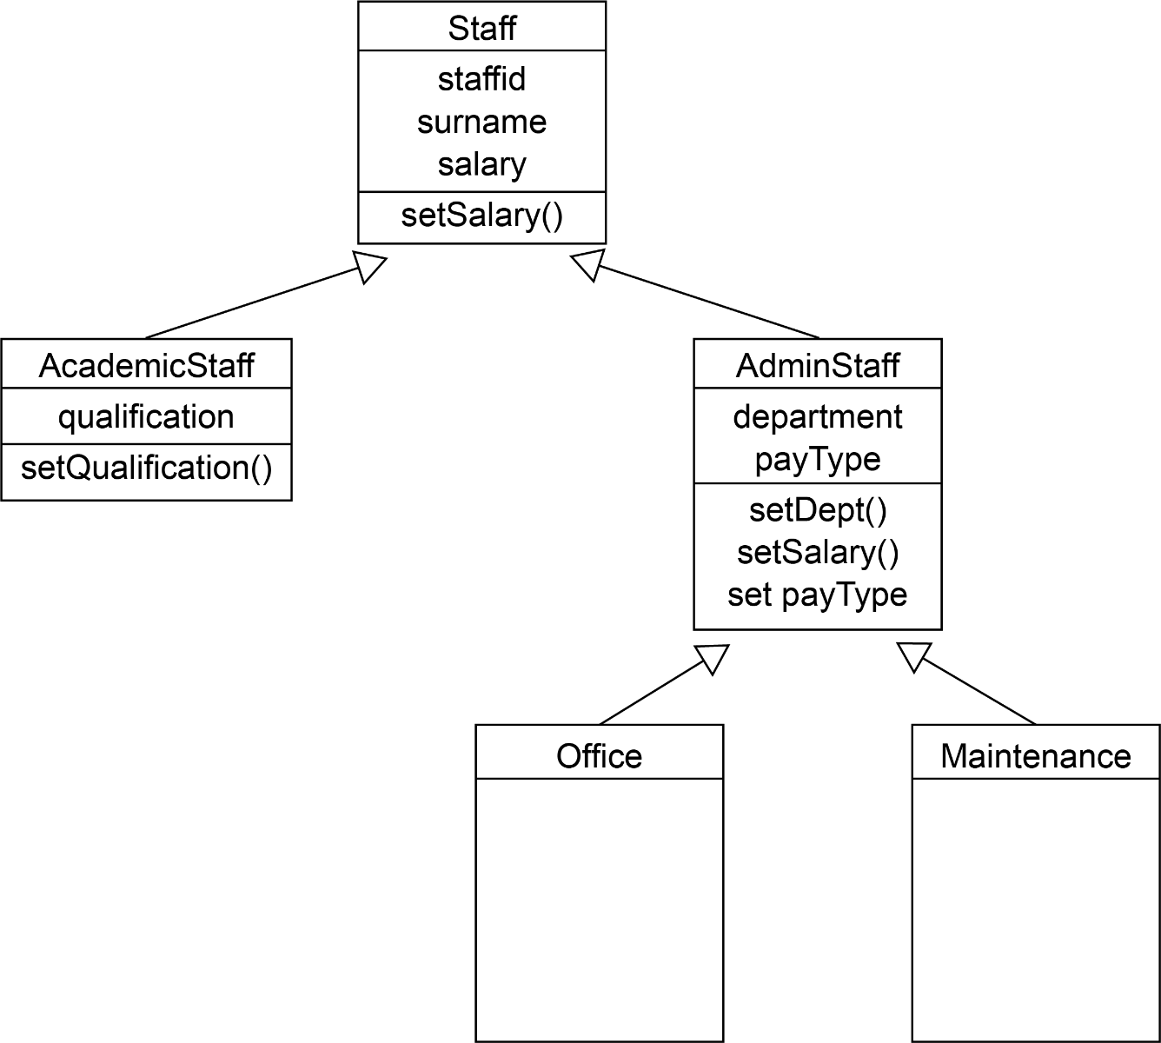

(a) What is this type of diagram called? [1]

(b) State the terms that describe

(i) setSalary() [1]

(ii) staffid [1]

(c) Explain the meaning of the arrows in the diagram, using an example. [2]

(d) Assume that AC123 has been defined as an object belonging to class AcademicStaff.

Explain why the statement

AC123.setSalary(30000)

is valid even though setSalary() is not shown in this part of the diagram. [2]

(e) Academic staff are paid a monthly salary. Administrative staff are paid either   
weekly or monthly, depending on their payType.

Explain why setSalary() appears in the description of both Staff and AdminStaff. [3]

[Total 20 marks]